**PROJECT REPORT TEMPLATE**

1. INTRODUCTION
   1. Overview
   2. Purpose
2. PROBLEM DEFINITION & DESING THINKING
   1. Empathy Map
   2. Ideation & Brainstorming Map
3. RESULT

* 1. Data Model:
  2. Activity & Screenshot

1. ADVANTAGES & DISADVANTAGES
2. APPLICATIONS
3. CONCLUSION
4. FUTURES

1. **INTRODUCTION**

**1.1 Overview**

If your business is open to the public, add in the cost of signage shelves, cash registers and payment systems. Calculate the cost of filling orders for the first few months, starting with how much money you need to keep your products in stock. Calculate shipping and packing costs if you mail items to customers.

**1.2 Purpose**

Estimates are documents that provide approximate costs for a project. Small businesses create them for potential clients so both parties are clear on the ins and outs of a project before it starts. FreshBooks has an estimates feature that help you build an quickly and easily.

**2. PROBLEM DEFINITION & DESIGN THINKING**

**2.1 Empathy map**



**2.2 Ideation & Brainstorming map**

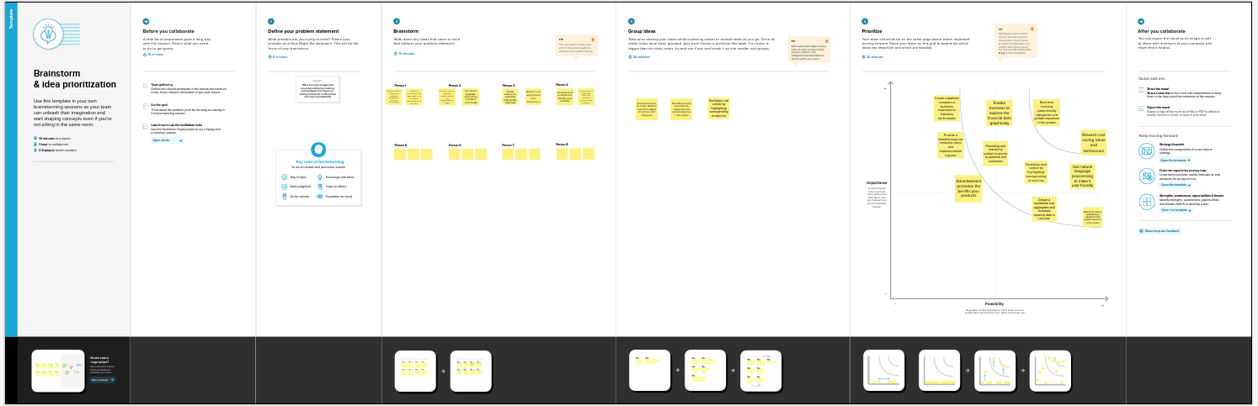

1. **RESULT**

**3.1 Data Model:**

|  |  |
| --- | --- |
| Object name | Fields in the object name |
| 1. Date | Number |
| 1. Description | Text |
| 1. Amount | Number |
| 1. category | Text |
| 1. Payment Method | Text |
| 1. Receipt/Attachment | Text |
| 1. Notes | Text |

**3.2 Activity & screenshots**

**Milestone 1: Define Problem / Problem Understanding**

**Activity 1: Specify the business problem**

This report developes into the fascinating realm of business expenses and provides a visual exploration of the various expenditures incurred by different businesses.

**Activity 2: Business requirements**

The primary business requirements for this report are to visualize and analyze business expenses, provide industry-specific insights, identify cost drivers, highlight outliers, and offer interactive functionality.

**Activity 3: Literature Survey**

Cost drivers were a significant focus in the literature survey, with researchers extensively investigating the factors influencing business expenses. Studies highlighted labour costs, material costs, overhead expenses, and marketing expenditures as key drivers.

**Activity 4: Social or Business Impact**

Social Impact: The analysis of business expenses and financial management has a significant social impact.

Business Impact: Analysing business expenses has a profound impact on various aspects of business operations.

**Milestone 2: Data Collection & Extraction**

Data collection is the process of gathering and measuring information on variables of interest, in an established systematic fashion that enables one to answer stated research questions, test hypotheses, evaluate outcomes and generate insights from the data.

**Activity 1: Downloading the dataset**

https://drive.google.com/file/d/1GFaQFRuccOHCnZKik_Rpfn5CUao8_INJ/view?usp=sharing

use the link to download the dataset

**Activity 1.1: Understand the data**

Data consists of 33 rows which correspond to 33 different business types and 29 columns that correspond to different operating expenses.

Column Description of the Dataset:

naics_code : Unique code given to each business type

Business_types : Different Business Types present (33)

operating_expenses : Total Operating expenses

annual_payroll : Total yearly payment

employer_cost : Amount spent on employees

employer_costs_health_insurance : Amount spent on health insurance for employees

employer_costs_contribution_plans : Amount spent on retirement plans for employees

employer_costs_pension_plans : Amount spent on pension plans for employees

employer_costs_benefits : Amount spent to provide various benefits to the employees

contract_labor_costs : Amount spent on contract labourers

expensed_equipment_amount : Amount spent on equipment

packaging_materials_and_containers: Amount spent on packaging

parts_and_supplies_not_for_resale: Amount spent on necessary parts and supplies not for sale

purchases_of_software: Amount spent to purchase software

data_processing_and_computer_services: Amount spent to computer services

commission_expense_amount : Amount spent on commissions given to employees based on their performance

communication_services: Amount spent on transmission and reception of data.

repairs_and_maintenance_of_equipment : Amount spent on repairs and maintenance

maintenance_of_buildings_offices: Amount spent on maintenance of buildings

rental_payment_for_machinery: Amount spent on leasing machinery

rental_payments_for_buildings_offices: Amount spent on leasing buildings for offices

electricity: Amount spent on electricity

water_sewer_and_other_utility: Amount spent on water sewer treatment

transportation_shipping_warehousing: Amount spent on transport, shipping and warehousing.

advertising_and_promotional_services: Amount spent on advertising

professional_and_technical_services: Amount spent on technical services

depreciation_and_amortization: Amount of depreciation

taxes_and_license: Amount spent on taxes and licenses

**Activity 2: Connect Dataset with Tableau**

Add the data set file in the text option and the data set will be connected

Milestone 3: Data Preparation

**Activity 1: Prepare the Data for Visualization**

This process helps to make the data easily understandable and ready for creating visualizations to gain insights into the performance and efficiency.

**Milestone 4: Data Visualization**

Data visualization is the process of creating graphical representations of data to help people understand and explore the information. The goal of data visualization is to make complex data sets more accessible, intuitive, and easier to interpret. By using visual elements such as charts, graphs, and maps, data visualizations can help people quickly identify patterns, trends, and outliers in the data.

**Activity 1: No of Unique Visualizations**

The number of unique visualizations that can be created with a given dataset. Some common types of visualizations that can be used to analyse the performance and efficiency of banks include bar charts, line charts, heat maps, scatter plots, pie charts, Maps etc.

**Activity 1.1 : Annual PayRoll**

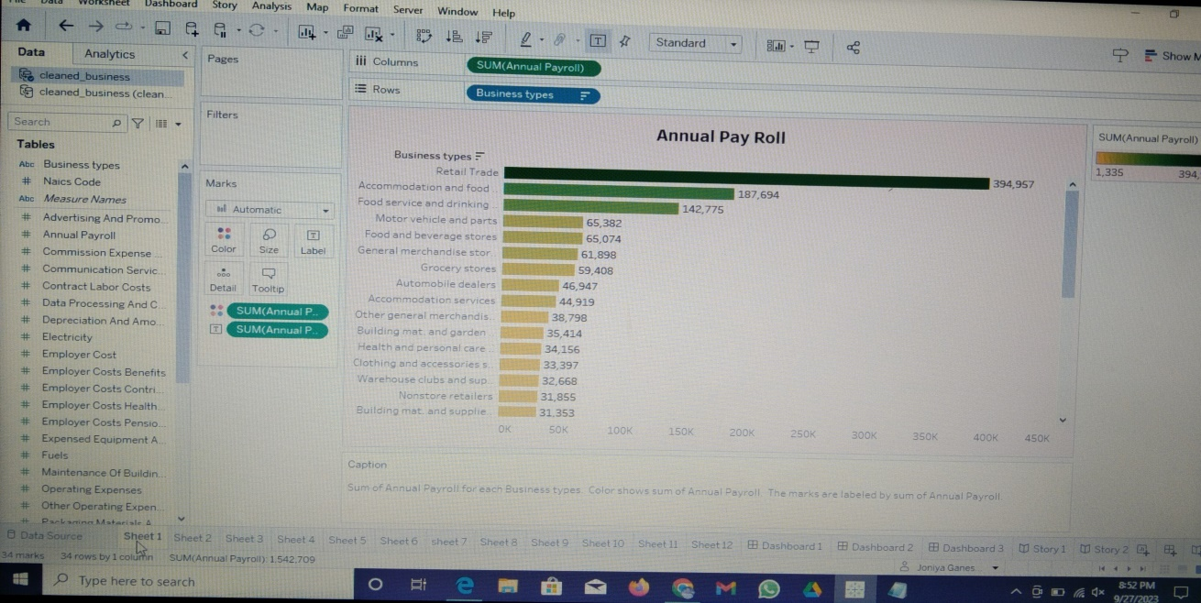

* Drag the Annual payroll into the column
* Then drag the Business types into the row

**Activity 1.2 : Advertisement Cost**

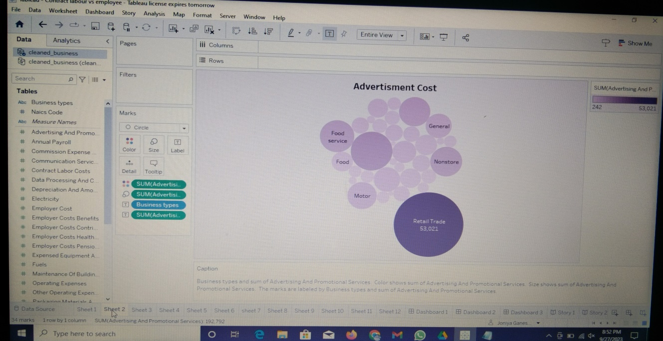

* Drag the Advertising and Promotional services into the column
* Then drag the Business types into the row

**Activity 1.3 : Contract Labour vs Employee**

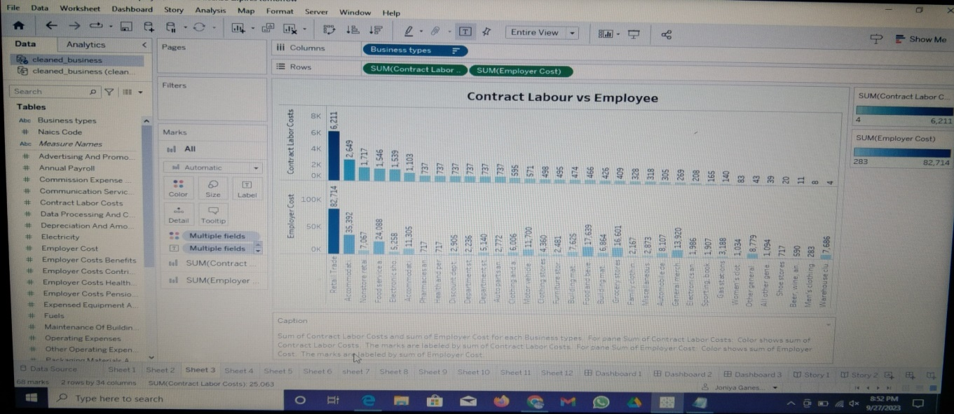

* Drag the Business types into the column
* Then drag the Contract labour cost and Employee cost into the row

**Activity 1.4 : Employee(Insurance vs pension)**

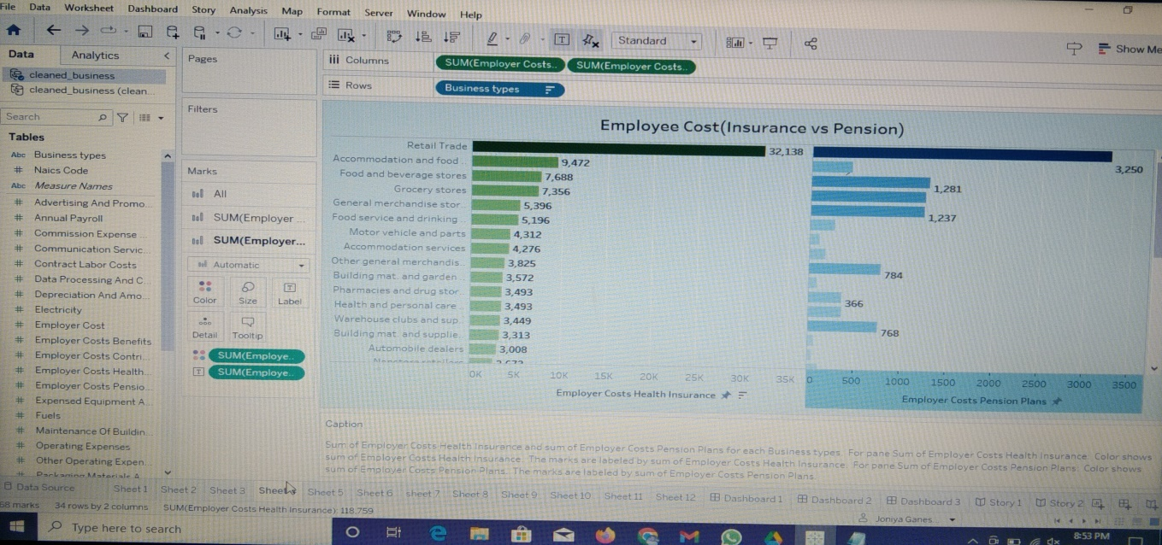

* Drag the Employee cost Insurance and pension into the column
* Then drag the Business types into the row

**Activity 1.5 : Equipment Costs**

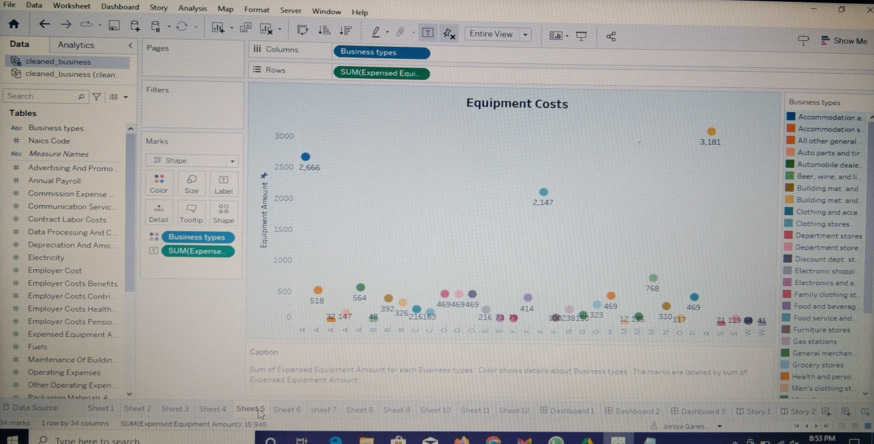

* Drag the Business types into the column
* Then drag the Expense Equipment cost into the row

**Activity 1.6 : Expenses YoY**

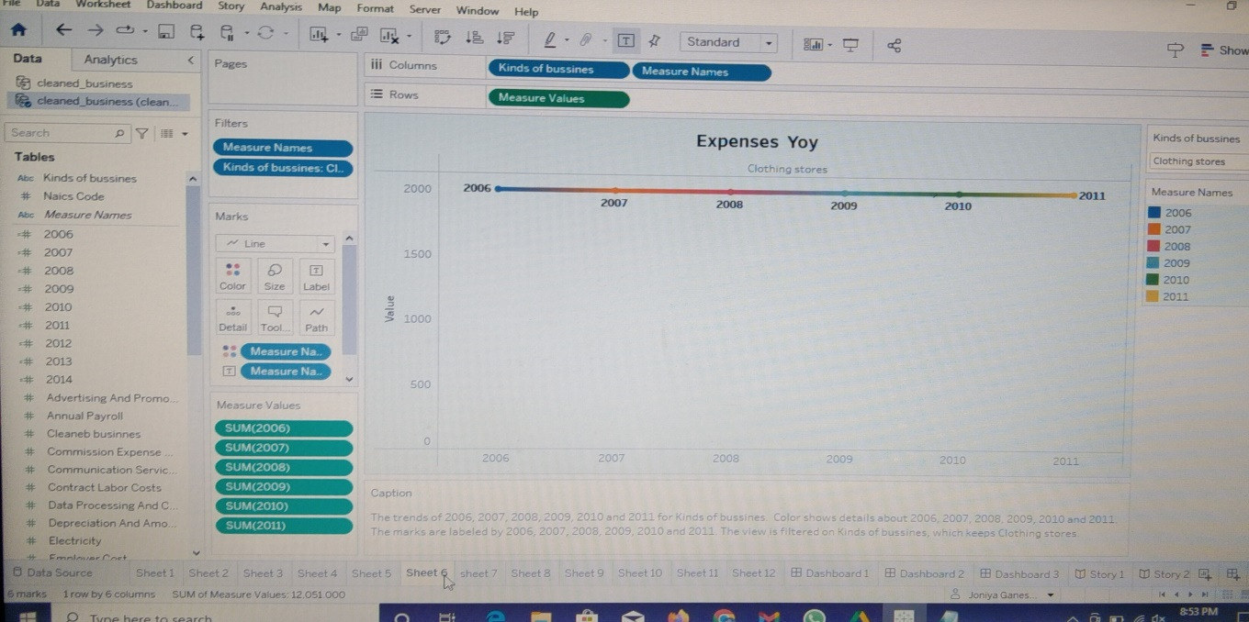

* Drag the Kind of business and Measure names into the column
* Then drag the Measure values into the row

**Activity 1.7 : Fuel**

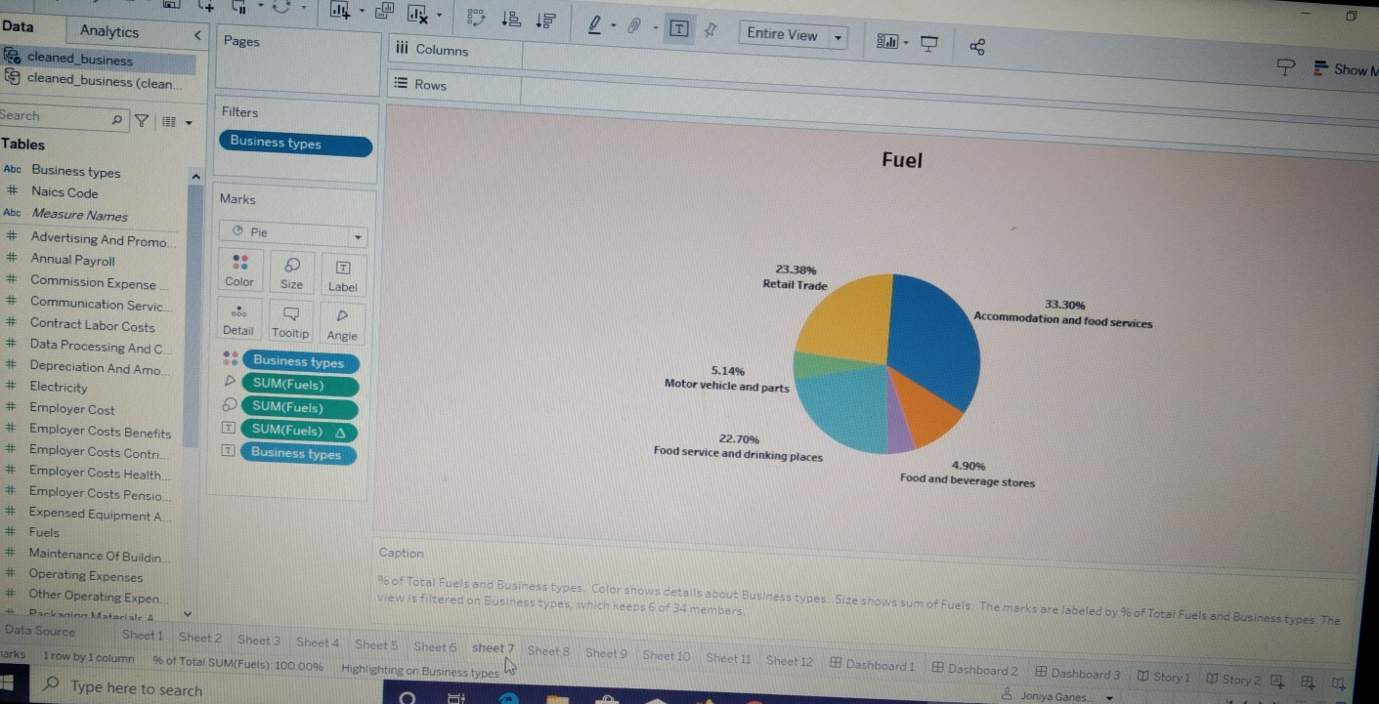

* Drag the Business types into the column
* Then drag the Fuel into the row

**Activity 1.8 : Maintenance of Buildings**

* Drag the Business types into the column
* Then drag the Maintenance of buildings into the row

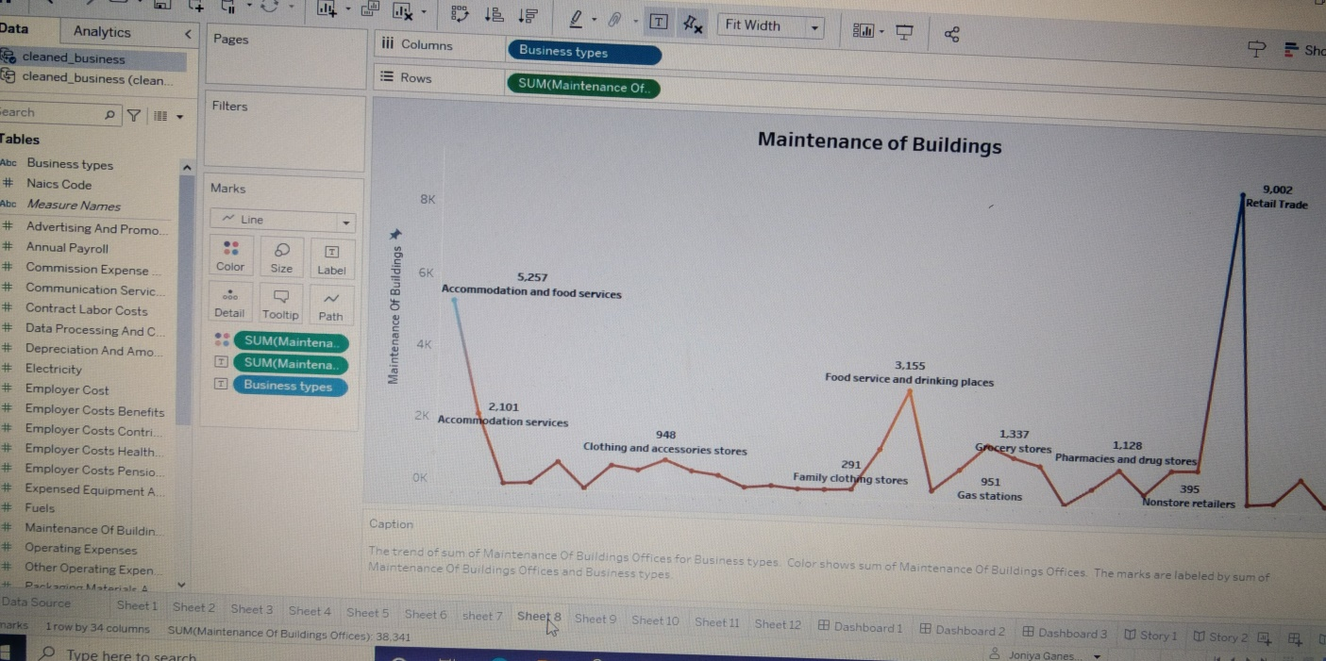

**Activity 1.9 : Power Expenditure**

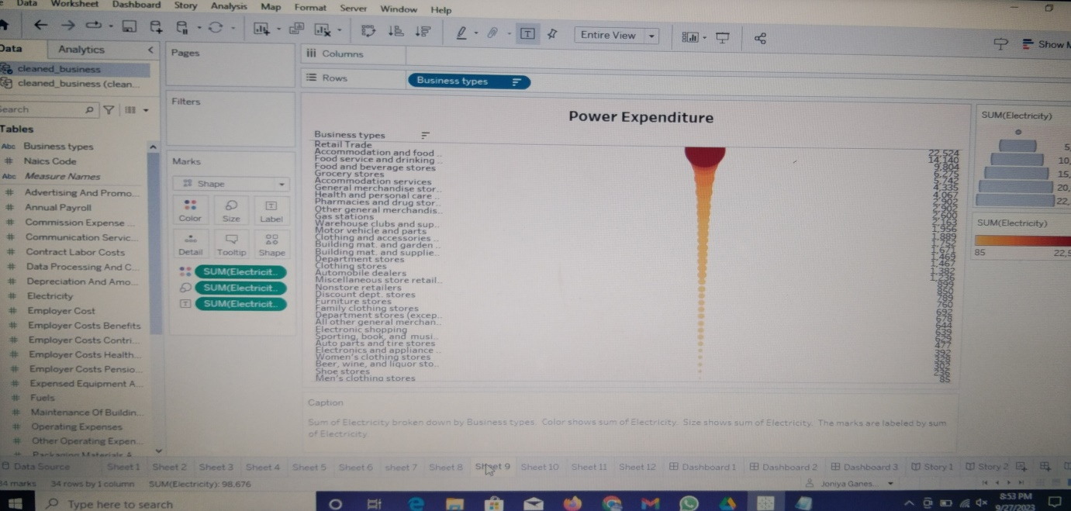

* Drag the Electricity into the column
* Then drag the Business types into the row

**Activity 1.10 : Rental Payment Machinery**

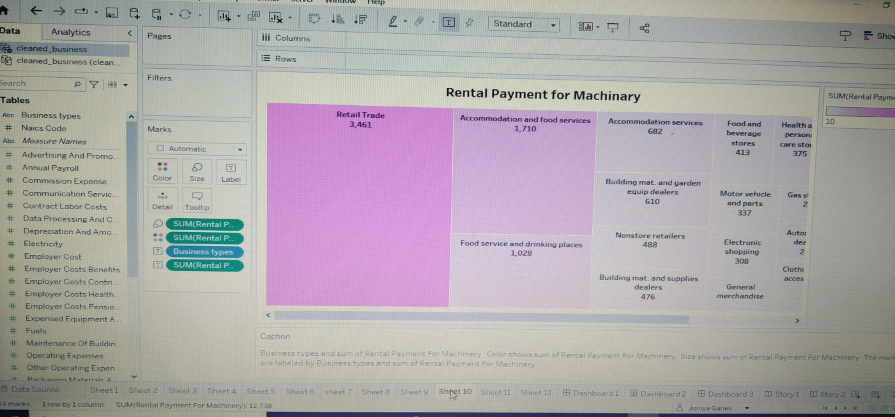

* Drag the Business types into the column
* Then drag the Rental payment into the row

**Activity 1.11 : Taxes & Licenses**

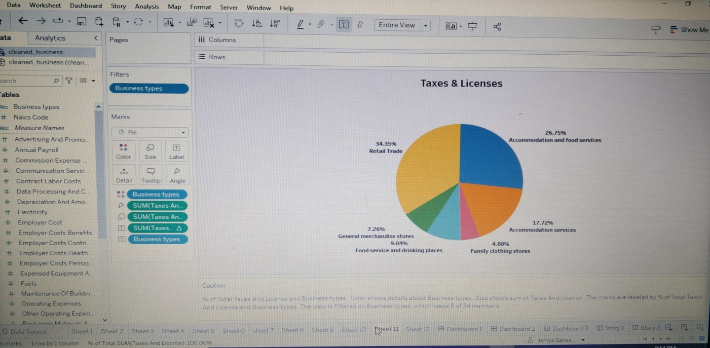

* Drag the Business types into the column
* Then drag the Taxes & Licenses into the row

**Activity 1.12 : Transportation**

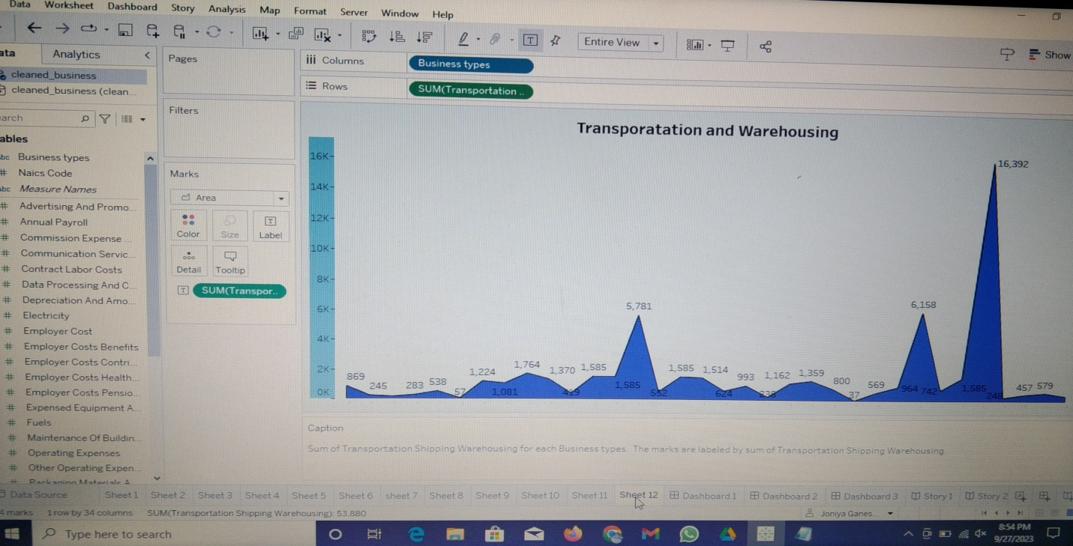

* Drag the Business types into the column
* Then drag the Transportations and Warehousing into the row

**Milestone 5: Dashboard**

A dashboard is a graphical user interface (GUI) that displays information and data in an organized, easy-to-read format. Dashboards are often used to provide real-time monitoring and analysis of data and are typically designed for a specific purpose or use case. Dashboards can be used in a variety of settings, such as business, finance, manufacturing, healthcare, and many other industries.

**Activity 1: Responsive and Design of dashboard**

Once you have created views on different sheets in Tableau, you can pull them into a dashboard.

**Activity 1.1 : Dashboard 1**

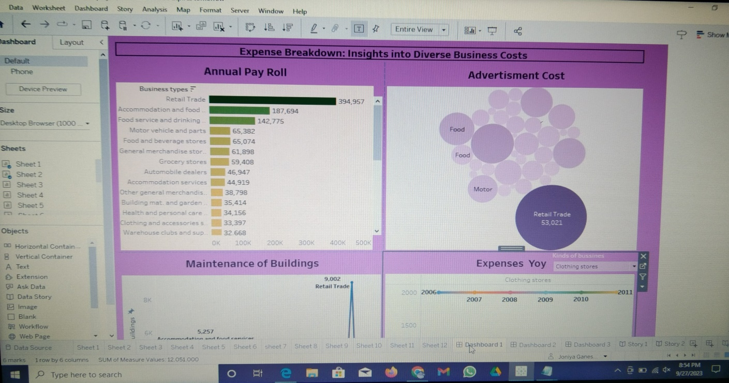

**Activity 1.2 : Dashboard 2**

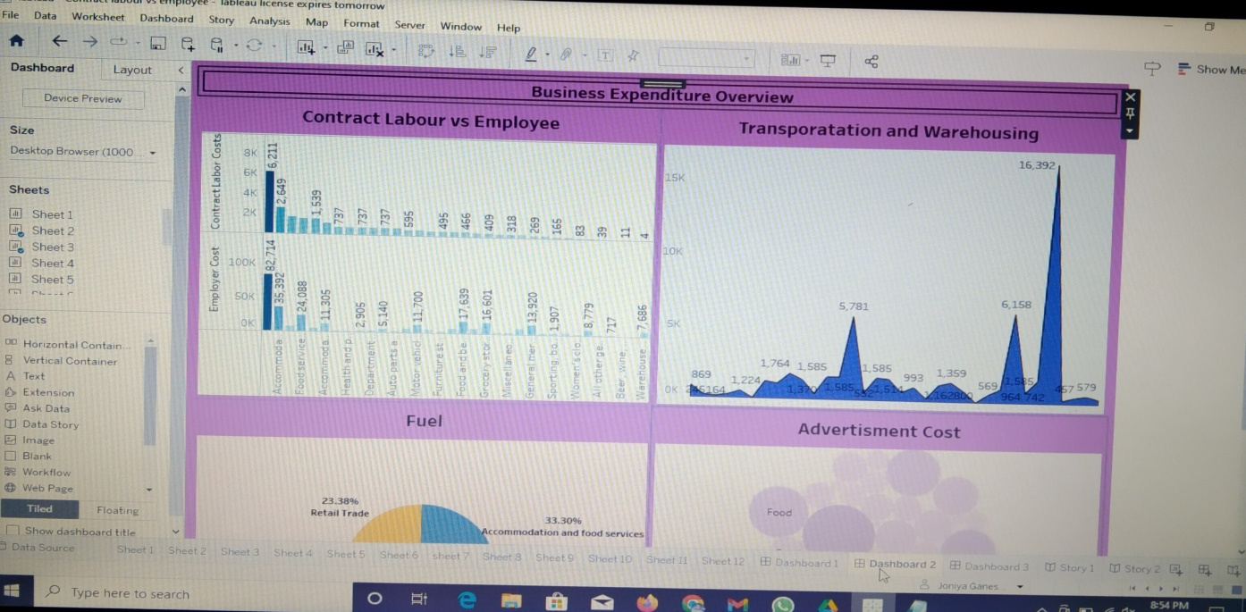

**Activity 1.3 : Dashboard 3**

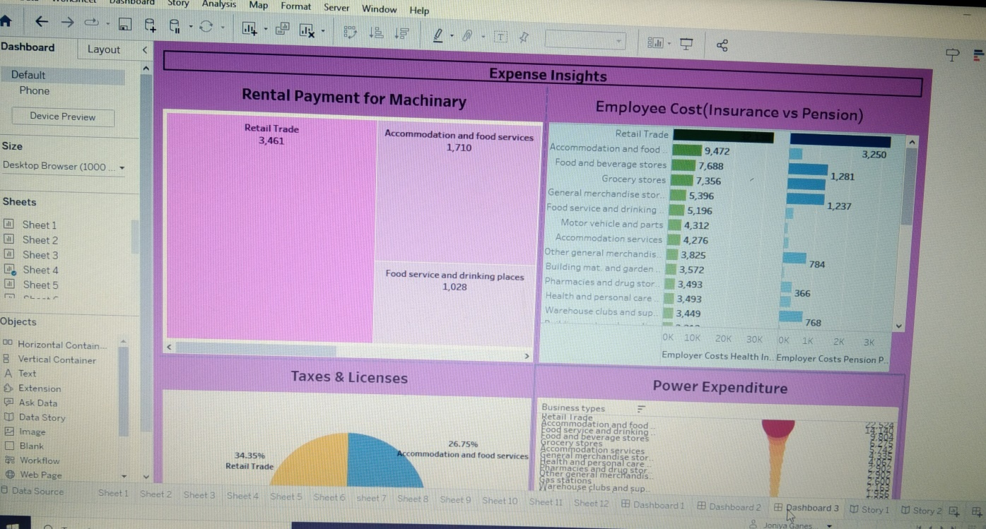

**Milestone 6: Story**

A data story is a way of presenting data and analysis in a narrative format, intending to make the information more engaging and easier to understand. A data story typically includes a clear introduction that sets the stage and explains the context for the data, a body that presents the data and analysis logically and systematically, and a conclusion that summarizes the key findings and highlights their implications. Data stories can be told using a variety of mediums, such as reports, presentations, interactive visualizations, and videos.

**Activity 1: Number of scenes in a story**

The number of scenes in a storyboard for a data visualization analysis of the performance of banks will depend on the complexity of the analysis and the specific insights that are trying to be conveyed. A storyboard is a visual representation of the data analysis process and it breaks down the analysis into a series of steps or scenes.

**Activity 1.1 : Story 1**

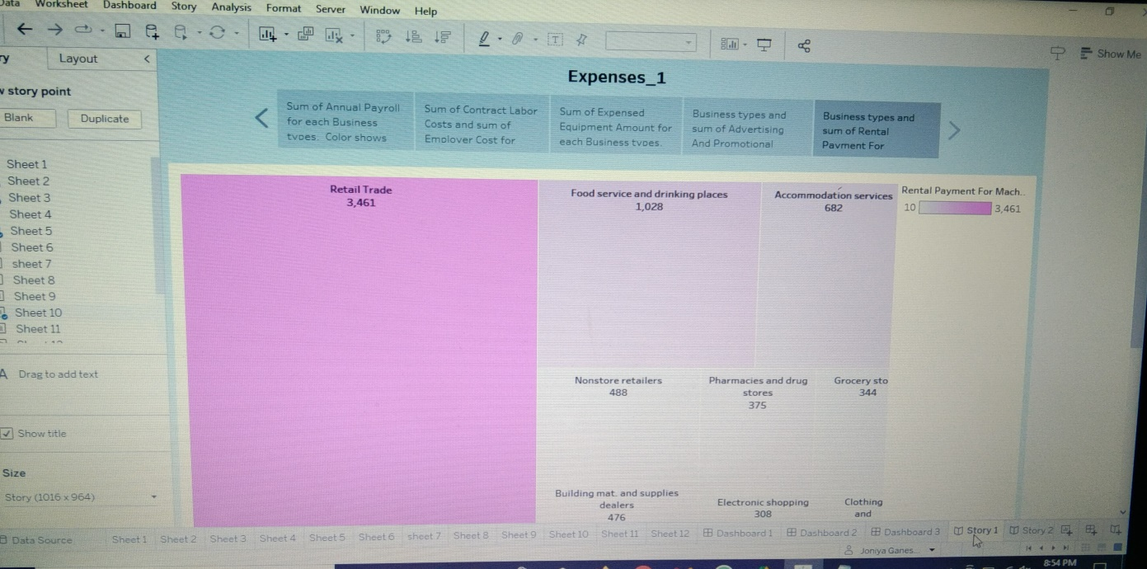

**Activity 1.2 : Story 2**

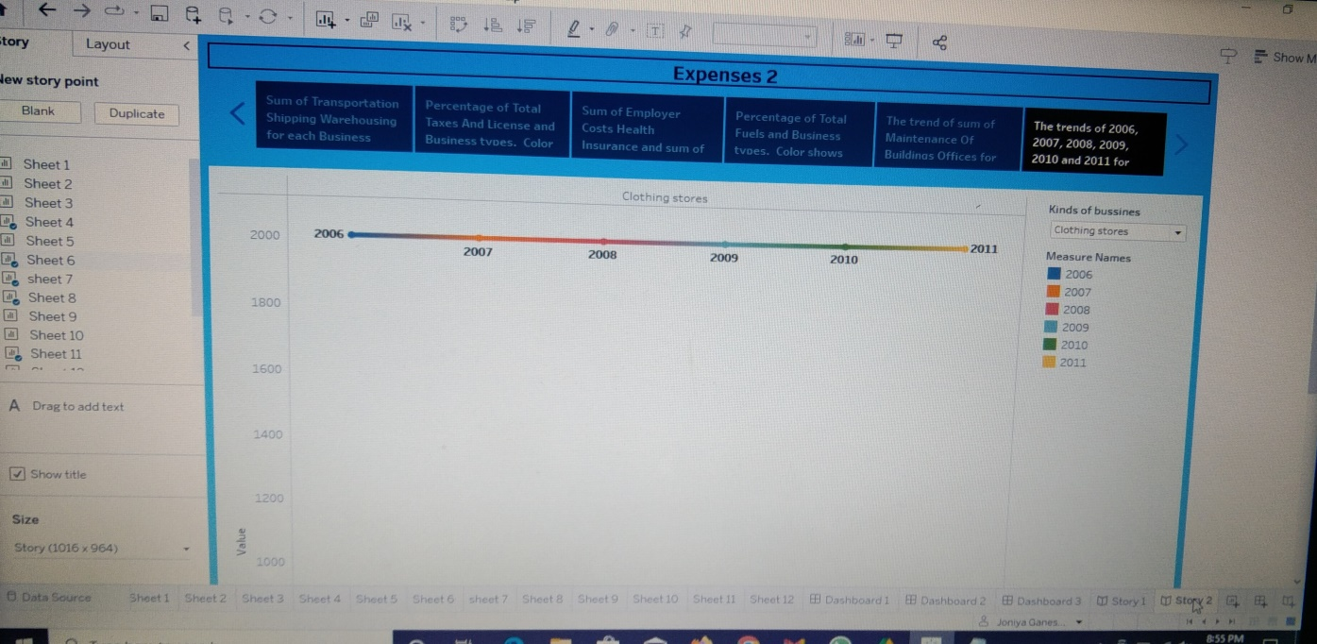

**Milestone 7: Performance Testing**

**Activity 1: Amount of Data Rendered to Tableau**

● The amount of data that is rendered to a Tableau depends on the size of the dataset

**Activity 2: Number of calculation fields**

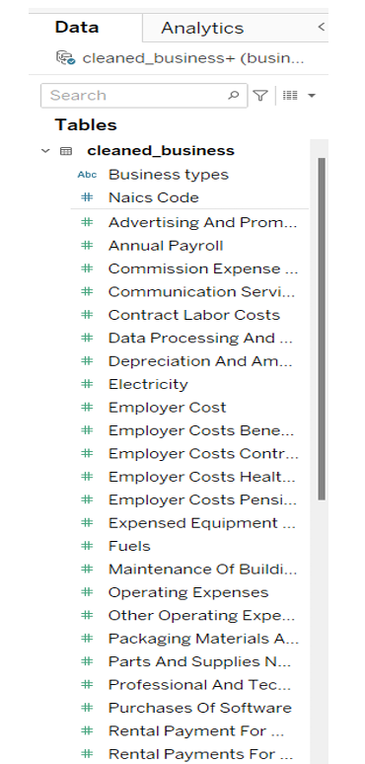

**Activity 3: Number of visualizations**

1. Annual Payroll

2. Advertisement Cost

3. Contract Labour vs Employee

4. Employee(Insurance vs pension)

5. Equipment Costs

6. Expenses YoY

7. Fuel

8. Maintenance of Buildings

9. Power Expenditure

10. Rental Payment Machinery

11. Taxes & Licenses

12. Transportation

**Milestone 8: Publishing**

Publishing helps us to track and monitor key performance metrics and to communicate results and progress. help a publisher stay informed, make better decisions, and communicate their performance to others.

**Publishing dashboard and reports to tableau public**

**Step 1 :** Go to data Source and Select Extract so that .hyper extension files are created and save it at your desktop. (please wait for pop up of file to save)

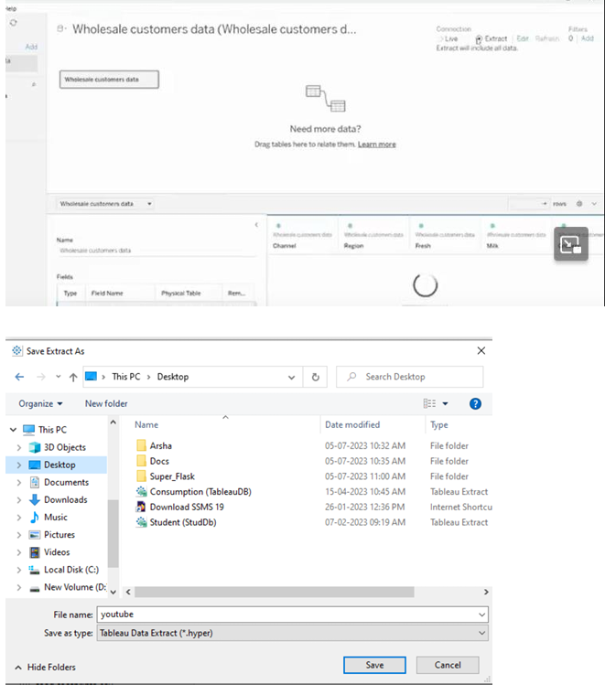

**Step 2**: Go to Dashboard/story, click on share button on the top ribbon

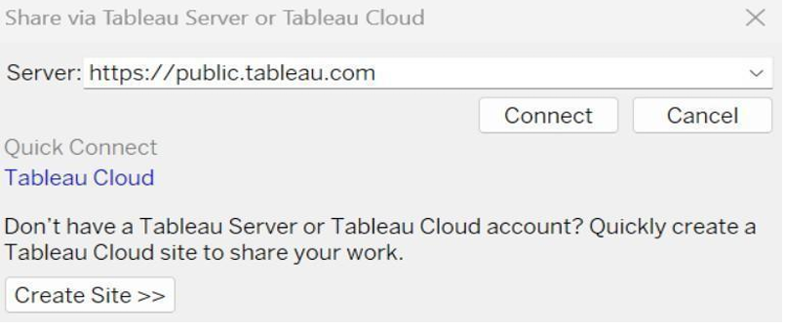

Give the server address of your tableau public account and click on connect.

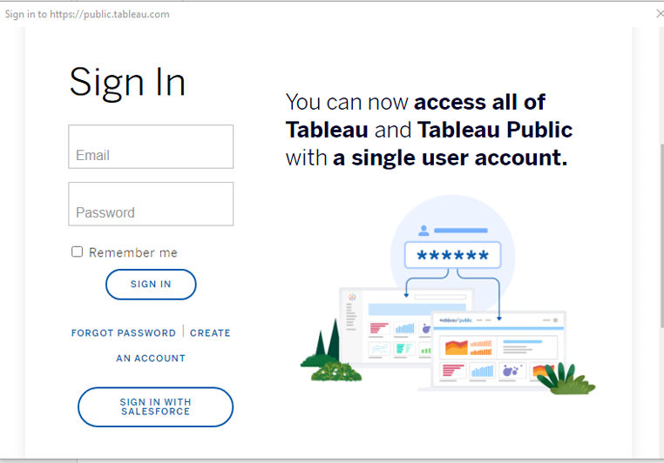

Sign in to your Tableau Public account or create a new account if you don't have one. You can visit the Tableau Public website (public.tableau.com) and click on the "Sign In" or "Join" button.

In the "Tableau Public Sign In" window, enter your Tableau Public account credentials and click "Sign In.

" Next, you'll need to provide a title and description for your workbook. Fill in the appropriate details in the provided field of workbook Title

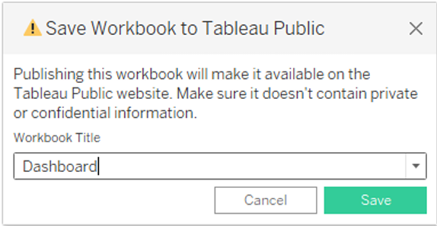

Click on the "Save" button to start the publishing process. Tableau Desktop will upload your workbook to Tableau Public.

Once the upload is complete, a browser window will automatically open, displaying your published workbook on Tableau Public. Review the workbook to ensure that everything appears as expected.

So in Similar way we can also publish Story to tableau public.

**Activity 1: Publishing dashboard and reports to tableau public**

**Team Member 1:**

**Dashboard 1:**

<https://public.tableau.com/app/profile/m.dharshini.mayalagu/viz/ExpenseBreakdownInsightsintodiversebusinesscosts/Dashboard1?publish=yes>

**Dashboard 2:**

<https://public.tableau.com/app/profile/m.dharshini.mayalagu/viz/BusinessExpenditureOverview/Dashboard2?publish=yes>

**Dashboard 3:**

<https://public.tableau.com/app/profile/m.dharshini.mayalagu/viz/ExpenseInsights/Dashboard3?publish=yes>

**Story 1:**

<https://public.tableau.com/app/profile/m.dharshini.mayalagu/viz/Expenses_1/Story1?publish=yes>

**Story 2:**

https://public.tableau.com/app/profile/m.dharshini.mayalagu/viz/Expenses_2_16957126670020/Story2?publish=yes

**Team Member 2:**

**Dashboard 1:**

<https://public.tableau.com/app/profile/joniya.ganesh.kumar/viz/ExpenseBreakdownInsightsintodiversebusinesscosts_16958641389240/Dashboard1?publish=yes>

**Dashboard 2:**

<https://public.tableau.com/app/profile/joniya.ganesh.kumar/viz/BusinessExpenditureOverview_16958655338880/Dashboard2?publish=yes>

**Dashboard 3:**

<https://public.tableau.com/app/profile/joniya.ganesh.kumar/viz/ExpenseInsights_16958701356380/Dashboard3?publish=yes>

**Story 1:**

<https://public.tableau.com/app/profile/joniya.ganesh.kumar/viz/Expenses_1_16958702499200/Story1?publish=yes>

**Story 2:**

<https://public.tableau.com/app/profile/joniya.ganesh.kumar/viz/Expenses2_16958703615390/Story2?publish=yes>

**Team Member 3:**

**Dashboard 1:**

<https://public.tableau.com/app/profile/indhu.mathi4605/viz/AnnualPayroll_16957444521520/Dashboard1?publish=yes>

**Dashboard 2:**

<https://public.tableau.com/app/profile/indhu.mathi4605/viz/AnnualPayroll_16957444521520/Dashboard2?publish=yes>

**Dashboard 3:**

<https://public.tableau.com/app/profile/indhu.mathi4605/viz/AnnualPayroll_16957444521520/Dashboard3?publish=yes>

**Story 1:**

<https://public.tableau.com/app/profile/indhu.mathi4605/viz/AnnualPayroll_16957444521520/Story1?publish=yes>

**Story 2:**

<https://public.tableau.com/app/profile/indhu.mathi4605/viz/AnnualPayroll_16957444521520/Story2?publish=yes>

**Team Member 4:**

**Dashboard 1:**

<https://public.tableau.com/app/profile/kanishka.sasikumar/viz/ExpenseWorkbookInsightsintoDiverseBusinessCaste/Dashboard1?publish=yes>

**Dashboard 2:**

<https://public.tableau.com/app/profile/kanishka.sasikumar/viz/BusinessExpenditureOverview_16957892145230/Dashboard2?publish=yes>

**Dashboard 3:**

<https://public.tableau.com/app/profile/kanishka.sasikumar/viz/ExpenseInsights_16957894383060/Dashboard3?publish=yes>

**Story 1:**

https://public.tableau.com/app/profile/kanishka.sasikumar/viz/Expense1_16958675948540/Story1?publish=yes

**Story 2:**

<https://public.tableau.com/app/profile/kanishka.sasikumar/viz/Expense2_16958677013180/Story2?publish=yes>

**Milestone 9: Project Demonstration & Documentation**

Below mentioned deliverables to be submitted along with other deliverables

**Activity 1: Record explanation Video for project end to end solution**

<https://drive.google.com/file/d/12j6T1HtLRsh1xirDY2tckjrWNvIWkPYW/view?usp=drivesdk>

**Activity 2: Project Documentation-Step by step project development procedure**

Create a document as per the template provided.

**4.Advantages & Disadvantages:**

**ADVANTAGES:**

1. Estimating expenses allows businesses to create budgets and allocate resources effectively. This helps in financial planning and ensures that funds are available for necessary expenditures.
2. It enables businesses to monitor and control costs. By having a clear estimate of expenses, companies can identify areas where they can cut unnecessary costs.
3. Estimating expenses helps in making informed decisions. It provides insights into the financial feasibility of projects and helps in evaluating the profitability of different strategies.
4. Effective expense estimation aids in managing cash flow. Knowing when and how much to spend helps maintain liquidity and prevents financial crises.
5. Accurate estimations help in tax planning, as businesses can anticipate their tax liabilities and take advantage of deductions and credits.

**DISADVANTAGES:**

1. Estimations are inherently uncertain and can be inaccurate. Unexpected expenses can arise, leading to budget shortfalls.
2. Creating detailed expenses estimates can be time-consuming. It may divert resources from other critical tasks.
3. In an attempt to be cautious, businesses may overestimate expenses, leading to underutilization of funds.
4. Underestimating expenses can lead to financial strain and potential disruptions in business operations.
5. Economic conditions and market dynamics can change rapidly to predict expenses accurately.

**5.Application:**

1. Estimating expenses is crucial for creating annual, quarterly, or project-specific budgets. This helps in planning how financial resources will be allocated and ensuring that funds are available for necessary expenditures.
2. Businesses use expense estimation to project future financial performance. It aids in predicting revenue, profitability, and potential cash flow issues.
3. Accurate expense estimation allows for proactive cost control measures. By comparing estimated expenses to actual spending, businesses can identify areas where costs can be reduced or optimized.
4. Estimating expenses is essential for setting product or service prices. It ensures that pricing covers all costs and generates a profit.
5. When considering new investments, such as equipment purchases, expansion, or acquisitions, estimating expenses helps evaluate the financial feasibility and potential return on investment.

**6.Conclusion:**

Categorize expenses into fixed and variable costs. This helps in understanding the nature of expenditures and their impact on profitability. Analyze past expense data to identify trends. Are expenses increasing, decreasing, or remaining stable? This can inform budgeting decisions.

Develop a comprehensive budget based on estimated expenses. Ensure that it aligns with revenue projections to maintain financial stability. Identify areas where cost control is essential. Are there any expenses that can be reduced or eliminated without affecting business operations?

Consider how expense estimates influence investment decisions. Will increased expenses lead to greater revenue, or should investments be scaled back? Recognize the importance of setting aside funds for unforeseen expenses. This can be crucial for handling emergencies or economic downturns.

Calculate the impact of estimated expenses on profit margins. Determine if adjustments are needed to maintain desired profitability level. Look for opportunities to improve operational efficiency, which can lead to cost savings and increased competitiveness.

Conclude that expense estimation is an ongoing process. Regularly review and update estimates to adapt to changing business conditions. Conclude that data –driven decisions based on expenses estimates are vital for the long-term financial health of the business.

**7.FUTURE SCOPE :**

Business will increasingly leverage data analytics and artificial intelligence to analyze historical expenditure data, identify patterns, and make more accurate predictions. Machine learning models can assist in forecasting expenses based on various factors, helping companies optimize their budgets.

Automation will play a significant role in expense estimation. Expense management systems and tools will become more advanced, automating tasks such as receipt scanning, categorization, and approval workflows, reducing human error and saving time.

Blockchain can enhance transparency and security in expense tracking. Smart contracts can automate expense approval and reimbursement processes while ensuring the integrity of transactions. With growing awareness of sustainability, business will need to estimate and manage expenses related to eco-friendly initiatives.

This includes investments in renewable energy, waste reduction, and other green practices. Companies expanding internationally will face challenges related to varying tax regulations and currency fluctuations. Advanced expense estimation tools will be required to handle these complexities.

Predictive analytics will become more sophisticated, helping business anticipate expenses in real time. This can be particularly beneficial in managing variable costs. As cyber threats continue to evolve, business will need to allocate resources for cybersecurity measures.